

aNUP kUMAR pANWAR

Let’s Go

An Open Source Book for learning Go Language…

Let’s Go

aNUP kUMAR pANWAR

**Author:**

[Anup Kumar Panwar](https://www.github.com/AnupKumarPanwar)

**Contributors:**

***Please Add You Name Here***

**Introduction**

Today is the era of Computer Science and more and more students are choosing software engineering as their career. The reason is probably handsome packages, wide range of opportunities and yes most important the name and fame.

Now when I talk about the name and fame, Google and Facebook that run the internet are the dream companies of all. Being a BE CSE student similar is my case. But before going through the interview process of such big firms an engineer must know what technologies they use and have a good hand over it. As the name suggests Go is Google’s Language. So this Open Source Book called “Let’s Go” will guide the beginners through the general purpose programming in Go Language.

For independent code and contribution to the book, find the source code at:

<https://www.github.com/AnupKumarPanwar/Lets-Go>

**So Let’s Get Started…..**

**INDEX**

1. Installation 3
2. Hello World Program 4
3. **INSTALLATION**
4. Go to <https://golang.org/dl/>
5. Download the setup file corresponding to your operation system and install it.

Let’s suppose you are using windows.

1. After installation open command prompt and type

“***go version***” (without quotes)

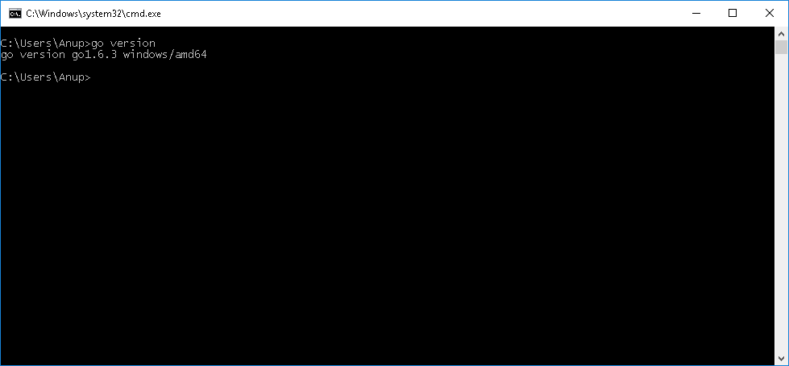\

1. If the result is similar to the above picture then be happy you can directly jump to the next chapter i.e., *Hello World Program*.
2. Else, if the command prompt displays something like

“**'go' is not recognized as an internal or external command, operable program or batch file.**”

Then you will need to add the Location of ***bin*** directory of go

Installed filesThe ***PATH*** in system variable.

1. For that ***Right Click*** on ***My Computer*** and go to ***Properties***.
2. Then click on ***Advance System Settings*** and then click on ***Environment variables****.*
3. Then in ***system variables*** double click on ***Path****,* then press ***New.*** Here paste the path of the ***bin*** folder of go installed files. In my case it is ***C:\Go\bin*.**

**Congrats you are now ready to learn Go Programming**

1. **HELLO WORLD PROGRAM**

Before we start with our Hello World Program I want you to make your environment more developer friendly. If you are still on basic text editor like Notepad then its ok but if you are using Sublime Text then it’s awesome. I recommend you to install Sublime Text.

Every go program must have a main packageand a main function. And for output we use the library called ***“fmt”*** (shorthand for format). The actual function available in this library that performs the output is ***Println()***.

*// Hello World Program*

**package** main

**import** "fmt"

**func** main() {

fmt.Println("Hello Wold")

}